**Module One** introduces you to different types of networks in the real world and why we study them. You will cover the basic elements of networks such as nodes, edges, and attributes and different types of networks such as directed, undirected, weighted, signed, and bipartite. You will also learn how to represent and manipulate networked data using the NetworkX library. The assignment will give you an opportunity to use NetworkX to analyze a networked dataset of employees in a small company, their relationships, and preferences of movies to watch for an upcoming movie night.

In **Module Two**you will learn about how to analyze the connectivity of a network based on measures of distance, reachability, and redundancy of paths between nodes. This type of analysis will allow you explore the robustness of a network when it is exposed to random or targeted attacks such as the removal of nodes and edges. In the assignment, you will practice using NetworkX to compute measures of connectivity of a network of email communication among the employees of a mid-size manufacturing company.

In **Module Three** you will explore ways of measuring the importance or centrality of a node in a network. You will cover several different centrality measures including Degree, Closeness, and Betweenness centrality, Page Rank, and Hubs and Authorities. You will learn about the assumptions each measure makes, the algorithms we can use to compute them, and the different functions available on NetworkX to measure centrality. You will also compare the ranking of nodes by centrality produced by the different measures. In the assignment, you will practice choosing the most appropriate centrality measure on a real-world setting, where you are tasked with choosing a person from a social network who should be given a promotional voucher in order to maximize the impact of the promotion on the network.

In **Module Four** you will explore the evolution of networks over time. You will learn about different models that generate networks with realistic features such as the Preferential Attachment Model and Small World Networks. You will also explore the link prediction problem, where you will learn useful features that can predict whether a pair of disconnected nodes will be connected in the future. In the assignment, you will be challenged to identify which model generated a given network. Additionally, you will have the opportunity to combine different concepts of the course by predicting the salary, position, and future connections of the employees of a company using their logs of email exchanges.

Module 1 (Week 1):

Examples of Network:

Transport Network, Mobility Networks, Social Networks, Information Networks (connections between articles)

Applications of Network analysis:

1. Is a rumor likely to spread in a social network? How long does it take to spread?
2. Who are the most influential person based on the social network?
3. Is the social network going to split into two groups? And if so, which nodes will go to which group?
4. Which airports are at most risk for virus spreading?
5. Are some parts of the world more difficult to reach?

Network definition: a representation of connections (edges) between a set of items (nodes)

Symmetric Network: no directions in the edges (undirected)  
Asymmetric Network: there are directions in the edges (directed)  
Weighted Network: there are weights on the edges (weighted)  
Signed Network: there are only opposite signs on the edges instead of weights (signed)  
Relation Network: there are categories on the edges (relations)  
Multigraphs: A pair of nodes can have multiple edges

Import networkx as nx  
G = nx.Graph()  
G.add_edge(‘A’,’B’)  
G.add_edge(‘B’,’C’)

G = nx.DiGraph()  
G.add_edge(‘A’,’B’)  
G.add_edge(‘B’,’C’)

G = nx.Graph()  
G.add_edge(‘A’,’B’, weight = 6)

G = nx.Graph()  
G.add_edge(‘A’,’B’, sign = ‘+’)

G = nx.Graph()  
G.add_edge(‘A’,’B’, relation = ‘Monkey’)

G = nx.MultiGraph()  
G.add_edge(‘A’,’B’, relation=’friend’)

nx.draw_networkx(G)

#List of all edges

G.edges() # Out: [(‘A’,’B’),(‘B’,’C’)]  
G.nodes()  
G.node[‘A’][‘role’]  
G.add_node(‘A’,role = ‘trader’)

#List of all edges with attributes

G.edges(data=True) # Out: [(‘A’,’B’,{‘relation’: ‘Monkey’}),(‘B’,’C’,{‘relation’:’friends’})]

#Accessing attributes for a specific edge

G.edge[‘A’][‘B’]

G.edge[‘A’][‘B’][‘weight’]

G.edge[‘A’][‘B’][0][‘weight’] # for multigraph

G.edge[‘A’][‘B’][1][‘weight’] # for multigraph

**Bipartite graphs**

Is a graph where there are only edges between 2 sets of nodes, no edges between the nodes within the same set

from network.algorithms import bipartite

B = nx.Graph()

B.add_nodes_from([‘A’,’B’,’C’,’D’,’E’], bipartite=0)

B.add_nodes_from([1,2,3,4], bipartite=1)

B.add_edges_from([(‘A’,1),(‘B’,1),(‘C’,1),(‘D’,2),(‘E’,3)])

bipartite.is_bipartite(B) # check if graph is bipartite

B.remove_edge(‘A’,’B’)

Bipartite_is_bipartite_node_set(B,X) # check if set of node is bipartite nodes

**Bipartite graph projection**this is to project the bipartite graph into only 1 of its set of nodes

B = nx.Graph()

B.add_edges_from([(‘A’,1),(‘B’,1)….])

X = set([‘A’,’B’,’C’,’D’,’E’,’F’…])

P = bipartite.projected_graph(B,X)

**Module Two**To measure the connectivity of a network via measures of distance, reachability, and redundancy of paths between nodes.

Local clustering coefficient: Fraction of pairs of the node’s friends that are friends with each other (Triangles closure)

Local clustering coefficient : # pairs of C’s friends who are also friends with one another / # of pairs of C’s friends

# pairs of C’s friends who are also friends with one another: just observe based on the graph

# of pairs of C’s friends: d_c * (d_c – 1) / 2

When the # of pairs of C’s friends = 0 then the local clustering coefficient = 0

G = nx.Graph()

G.add_edges_from( [ (‘A’,’K’),,,,,,] )

nx.clustering(G,’F’)

To calculate the global clustering coefficient, there are 2 approaches:

1. Average the local clustering coefficient for each node (puts equal weight across all nodes)
2. % of open triangles in a graph (puts larger weight on high degree nodes)

nx.average_clustering(G)

nx.shortest_path(G,’A’,’H’)

nx.shortest_path_length(G,’A’,’H’)

nx.average_shortest_path_length(G)

nx.diameter(G)

Breadth_first_search_tree() = nx.bfs_tree(G,’A’)

Breadth_first_search_tree.edges()

nx.eccentricity(G)

nx.periphery(G)

nx.center(G)

Paths: sequence of nodes connected by an edge.

Path Length / Distance: how many edges to hop from one node to another?

Diameter: maximum distance between any pair of nodes

Eccentricity: is the largest distance between n and all other nodes

Radius: radius of a graph is the minimum eccentricity

Breadth-first search: an approach to find the distance of all the nodes from a specified node

Breadth-first search

What are the nodes with distance 1? Distance 2? Distance 3?.... Until all the nodes are covered

Periphery: Periphery of a graph is the set of nodes that have eccentricity equal to the diameter

Center: center of a graph is the set of nodes that have eccentricity equal to the radius

Connected graphs

Definition: a graph is connected, if for every pair of nodes, there is a path from one node to the other node

nx.connected(G) # Out: True or False

nx.number_connected_components(G)

nx.is_strongly_connected(G)

nx.is_weakly_connected(G)

nx.strongly_connected_components(G)

nx.weakly_connected_components(G)

Connected components: are communities of nodes which follows the 2 assumptions:

1. Every node in the component has a path to all other nodes
2. No other node outside of the component has a path to any of the nodes in the component (Ensures there is no other possible smaller component)

A graph can be:

1. Strongly connected: if every pair of nodes, there is a directed path from one node to the other
2. Weakly connected: if the graph will be strongly connected when the directed edges are replaced with non-directed edges

Measuring robustness of networks. When we remove edges from a graph, is it still connected?

Network robustness: the ability of network/graph to maintain its general properties when it faces attacks

Types of attacks: Removal of edges or nodes or both

Structural properties: connectivity

Examples: airport closure, spread of virus in a network

Check connectivity if we remove nodes

nx.node_connectivity(G)

nx.minimum_node_cut(G) # Output number of nodes to cut

nx.minimum_node_cut(G,’A’,’H’) # Output which nodes to cut

Check connectivity if we remove edges

nx.edge_connectivity(G)

nx.minimum_edge_cut(G) # Output number of edges to cut

nx.minimum_edge_cut(G,’A’,’H’) # Output which edges to cut

Check the number of paths from one node to the other

nx.all_simple_paths(G,’A’,’H’)

len(nx.all_simple_paths(G,’A’,’H’))

Node Importance

We can say that nodes with a high degree = important nodes, or

Nodes who are very close to other nodes = important nodes, or

Nodes who have shortest paths that pass through the node = important nodes

The measure and identification of important nodes = Node Centrality

Why? Find influential nodes in a social network. Find important pages in a web. Find hubs in a transportation network. Nodes that disseminate information to many nodeas or prevent epidemics.

Different Centrality Measures

1. **Degree Centrality**
2. **Closeness Centrality**
3. Load Centrality
4. Page Rank
5. Betweenness Centrality
6. Katz Centrality
7. Percolation Centrality

Degree Centrality

Assumption: Important nodes have many connections.   
To measure centrality based on connections: This is to measure number of degrees (for undirected) and in-degree, out-degree (for directed graphs)

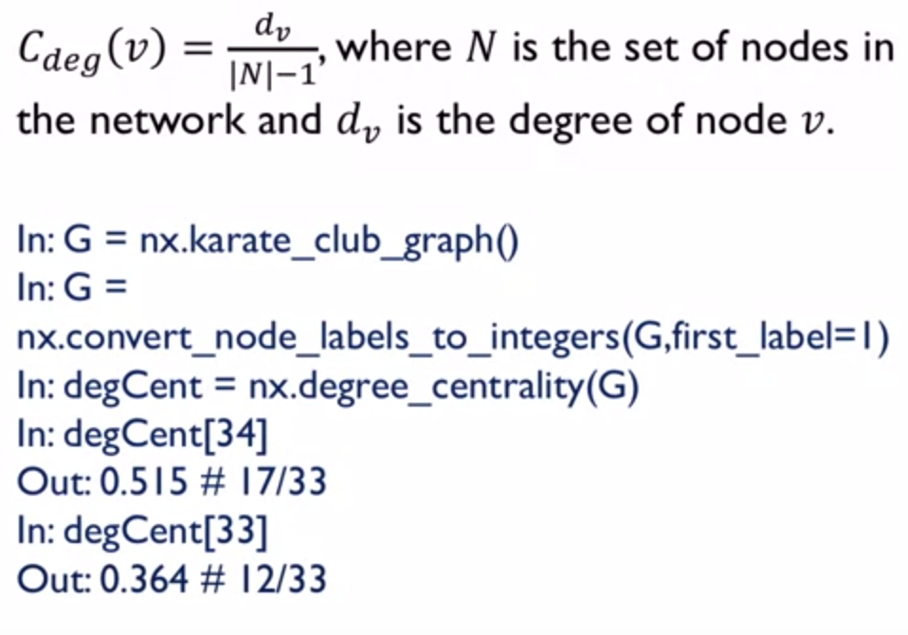

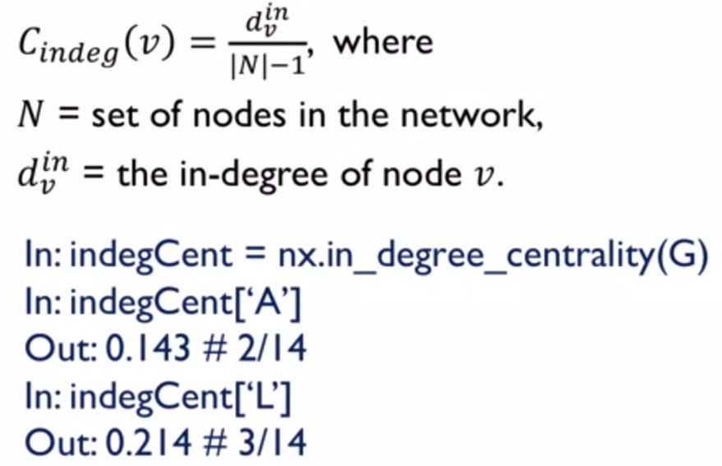

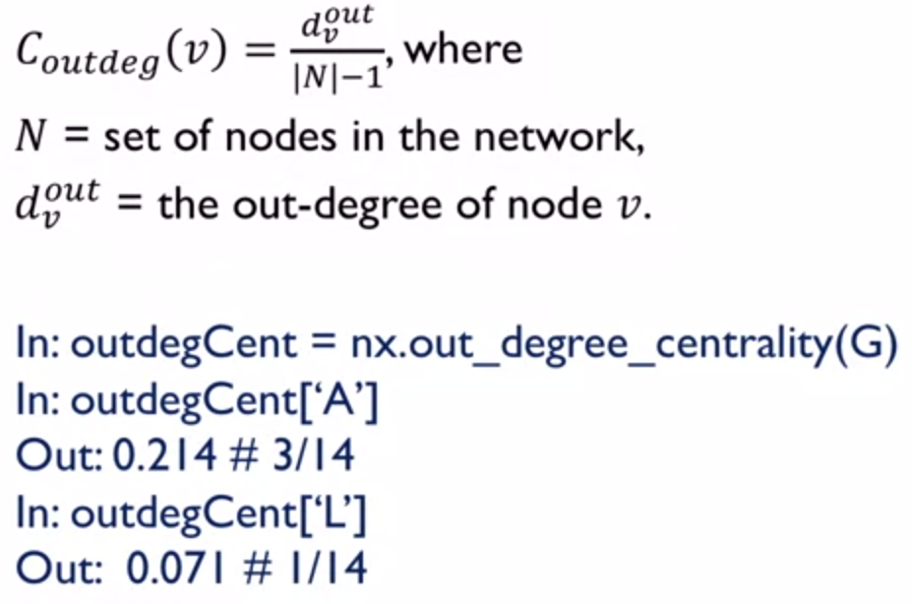

Closeness Centrality

Assumption: important nodes are close to other nodes = short distance from other nodes  
Assumption 2: That all nodes can reach to all other nodes, connectedness of a graph

This is a value between 0 to 1. 1 being a very close and central node.

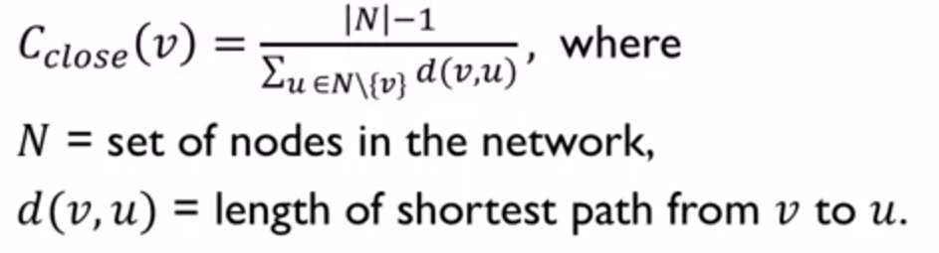

Ratio of number of nodes in graph against the shortest distance of all nodes to the specified node

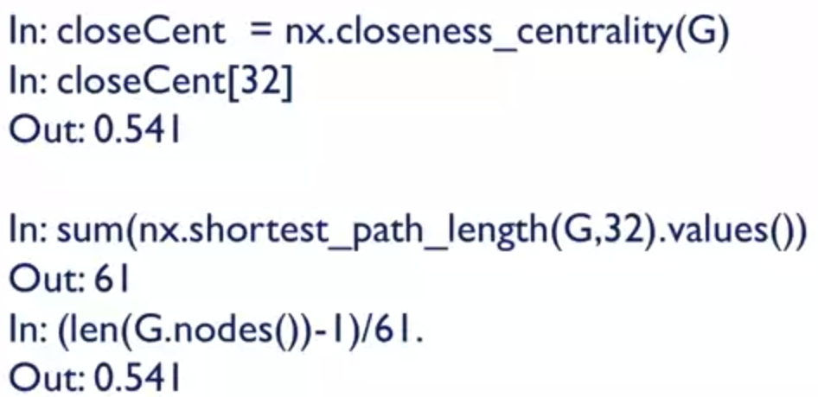

What is the approach when the graph is disconnected? Violation of assumption 2.

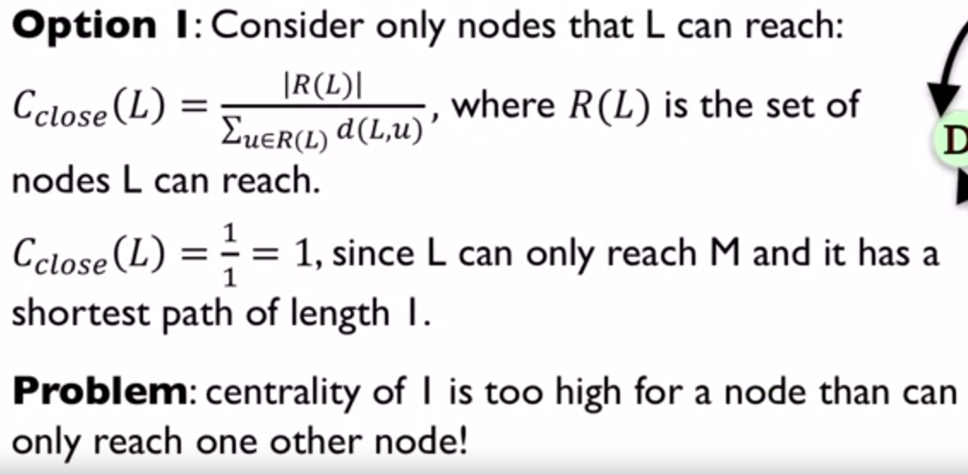

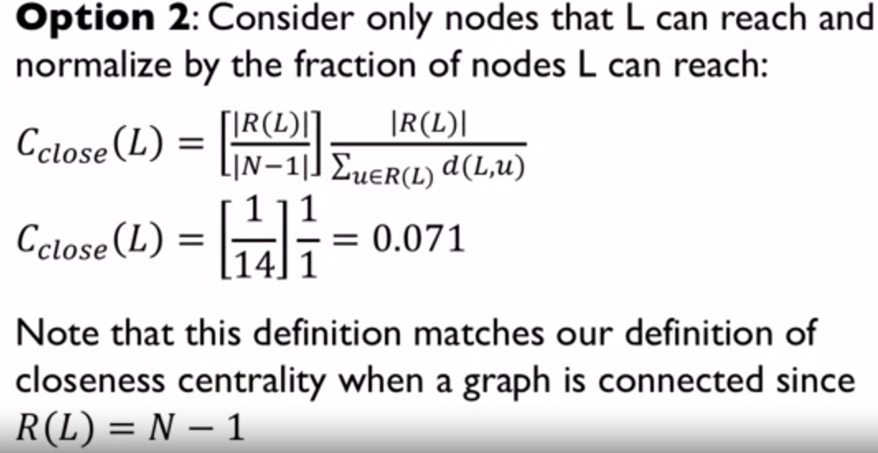

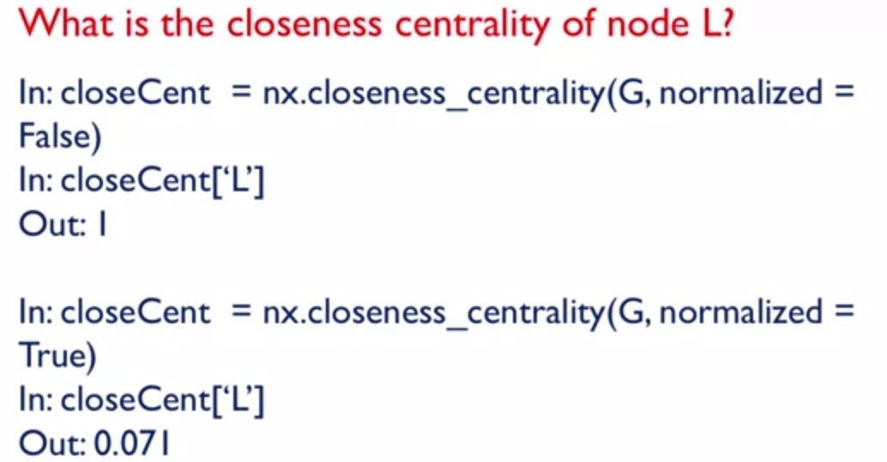

Betweenness Centrality

Assumption: important nodes connect other nodes  
Assumption 2: nodes can reach to all other nodes, connectedness of a graph

We are interested in finding out what nodes show up in the path, when we want to use the shortest path between node A and node B.

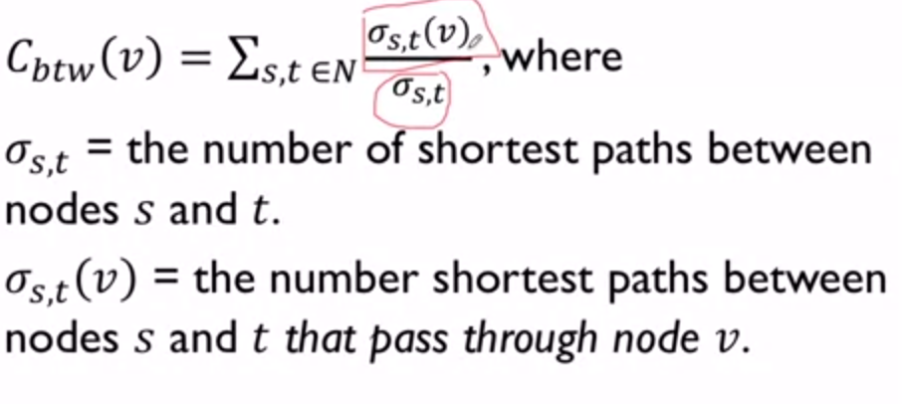

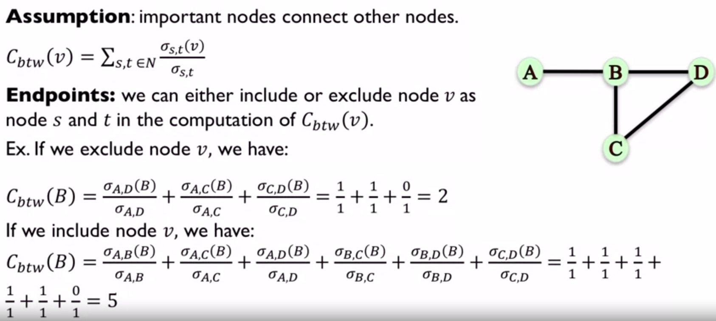

What happens if assumption 2 is violated?

Simply do not include the node that does not have a shortest path

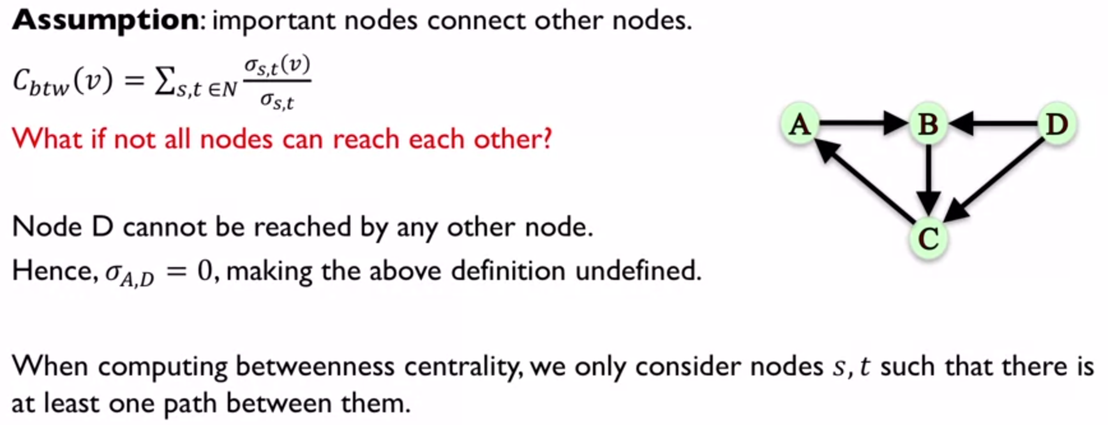

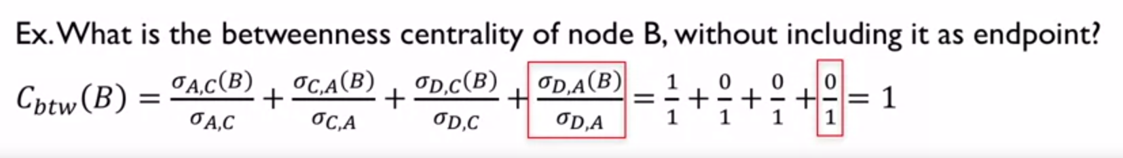

However, we need to normalize since graphs with larger number of nodes are more likely to have nodes which connect to more nodes.

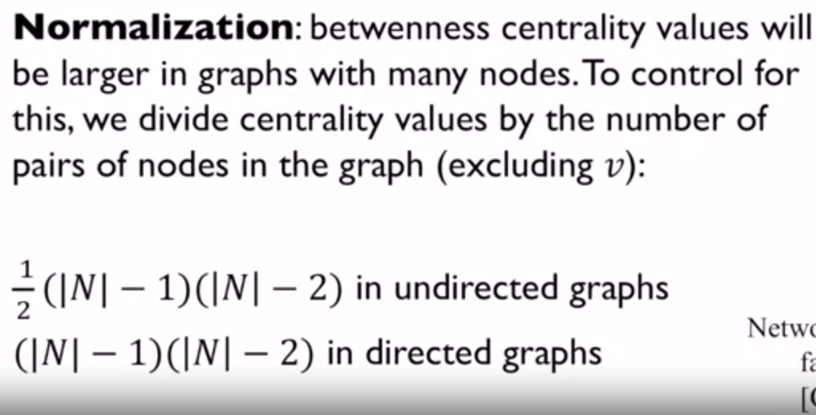

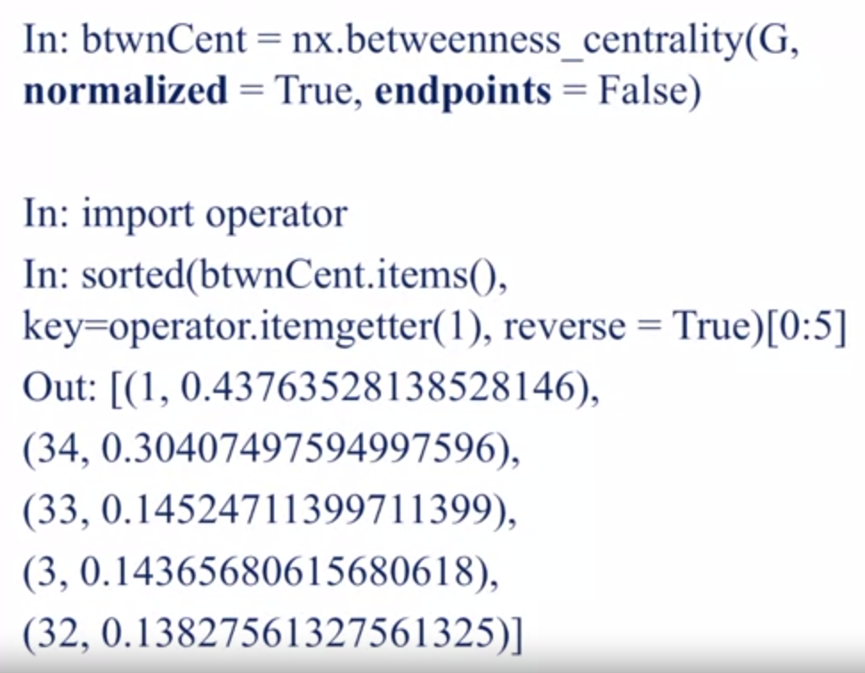

Computing the Betweenness centrality can be very computationally expensive. Computation has an order of O(N^3) time. Instead of computing based on all pairs of nodes, s, t, we can approximate it based on a sample of nodes.

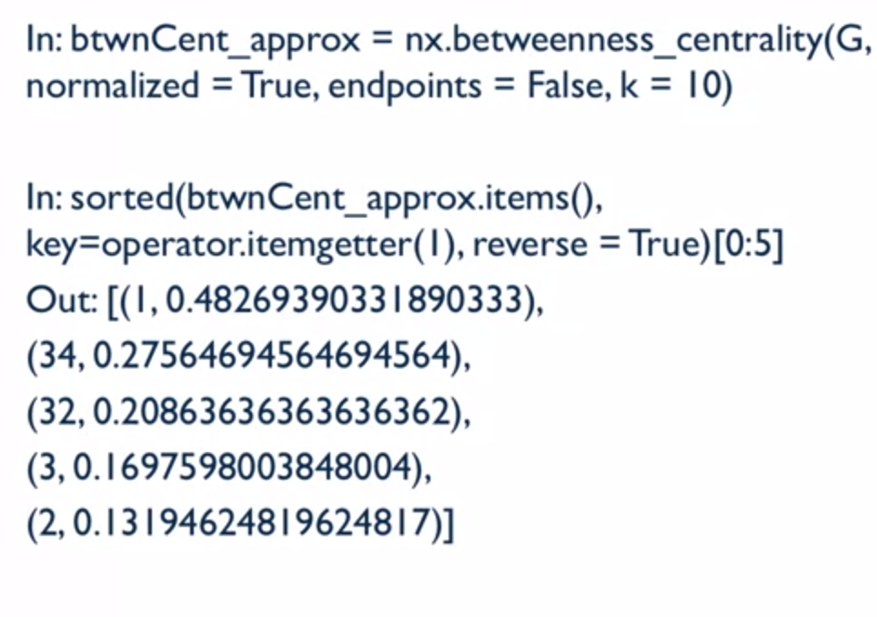  
The results are still similar. We select a batch of 10 nodes as a sample of nodes. Only node 33 is missing and replaced with node 2.

We also want to look at subsets of nodes in a graph and calculate the betweenness centrality between these 2 subsets. We want to understand how the subsets communicate with one another instead of looking at all pairs of nodes.

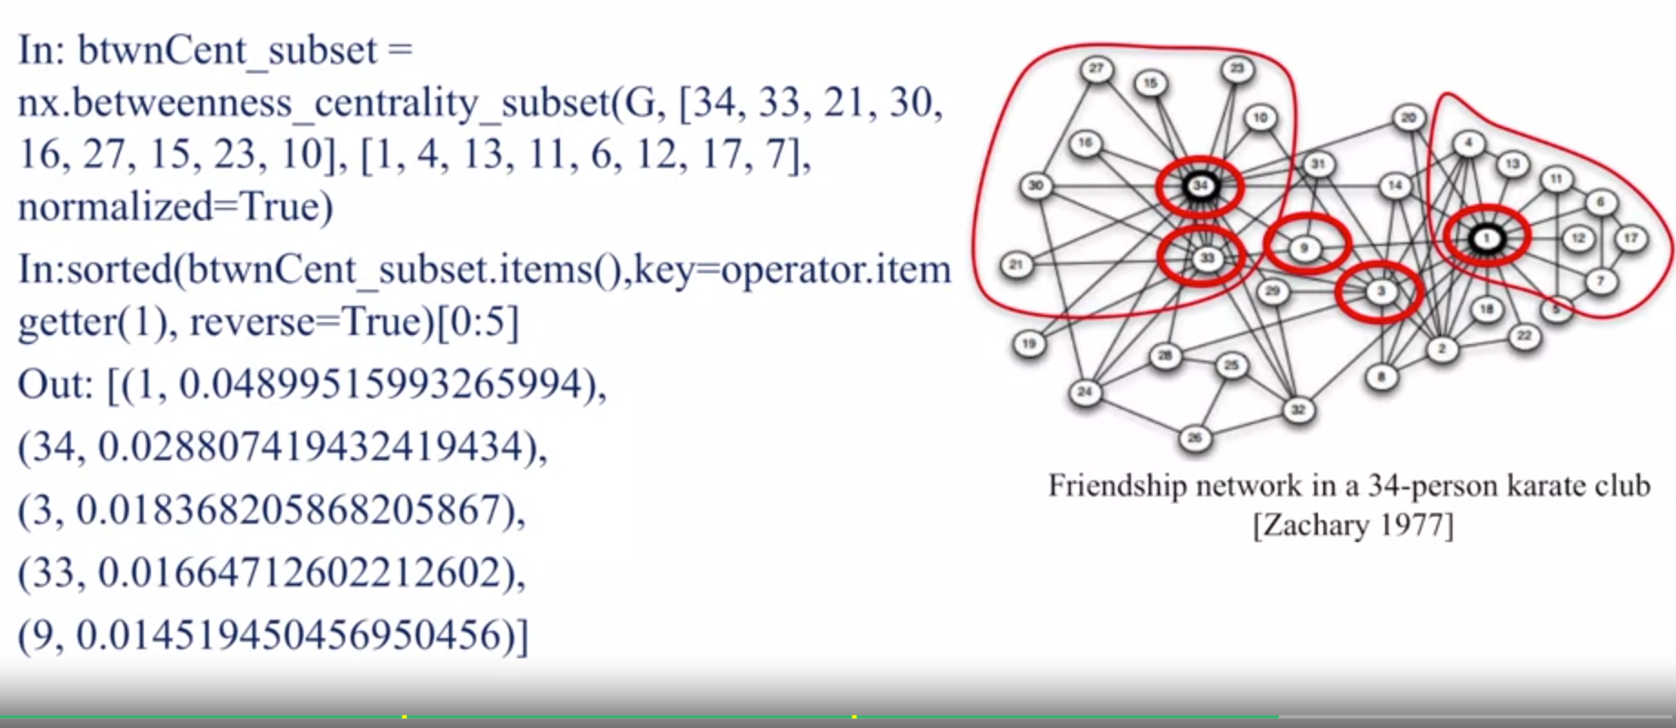

This is to find out which nodes are important to connect the set of Source nodes with the set of target nodes. So, the output nodes can contain nodes that are neither from source or the target set of nodes. E.g. node “9”

Calculating Betweenness centrality of edges

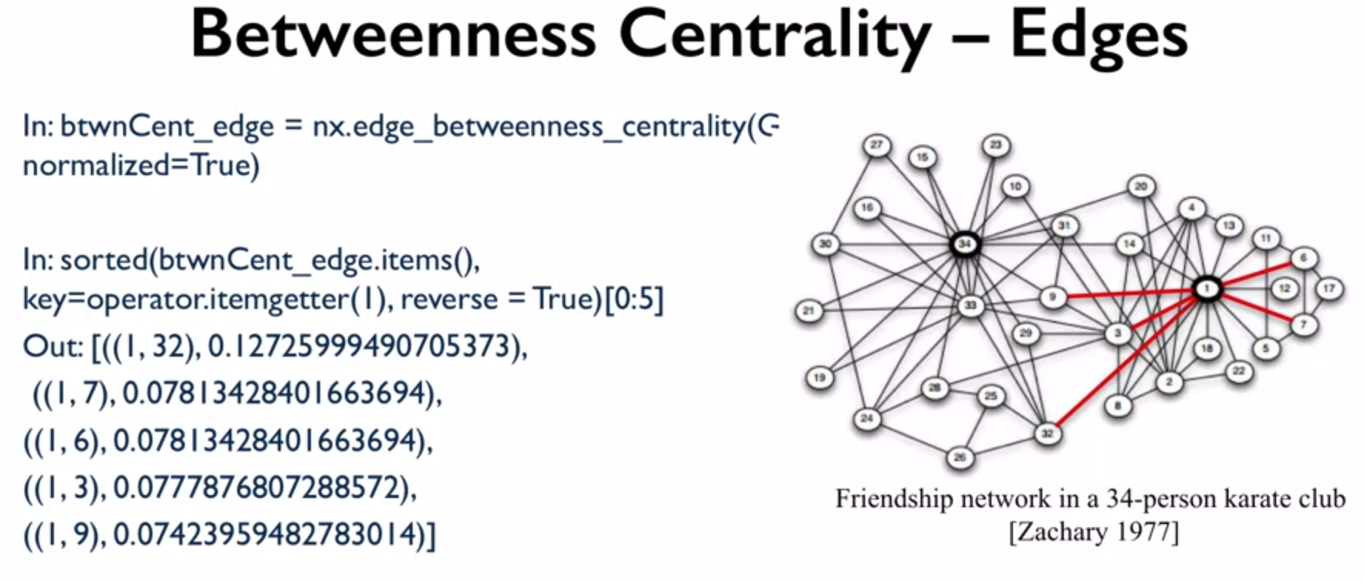

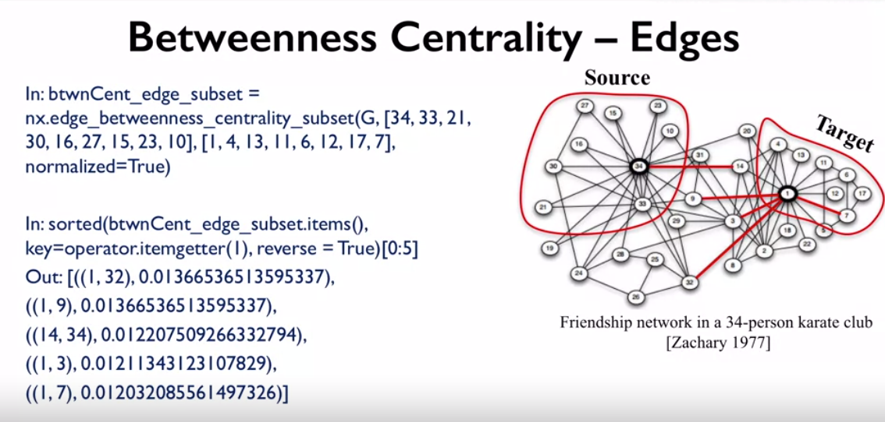

PageRank

Developed by Google founders to measure the importance of webpages. Works better with directed graphs. Assigns a score of importance to each node. A node’s pagerank depends on the pagerank of other nodes

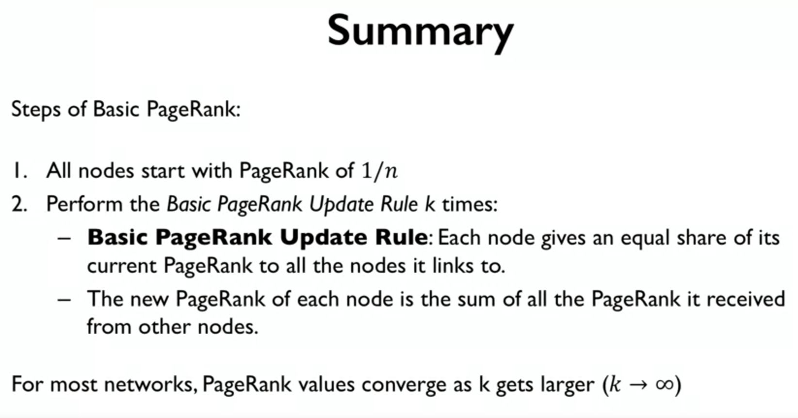

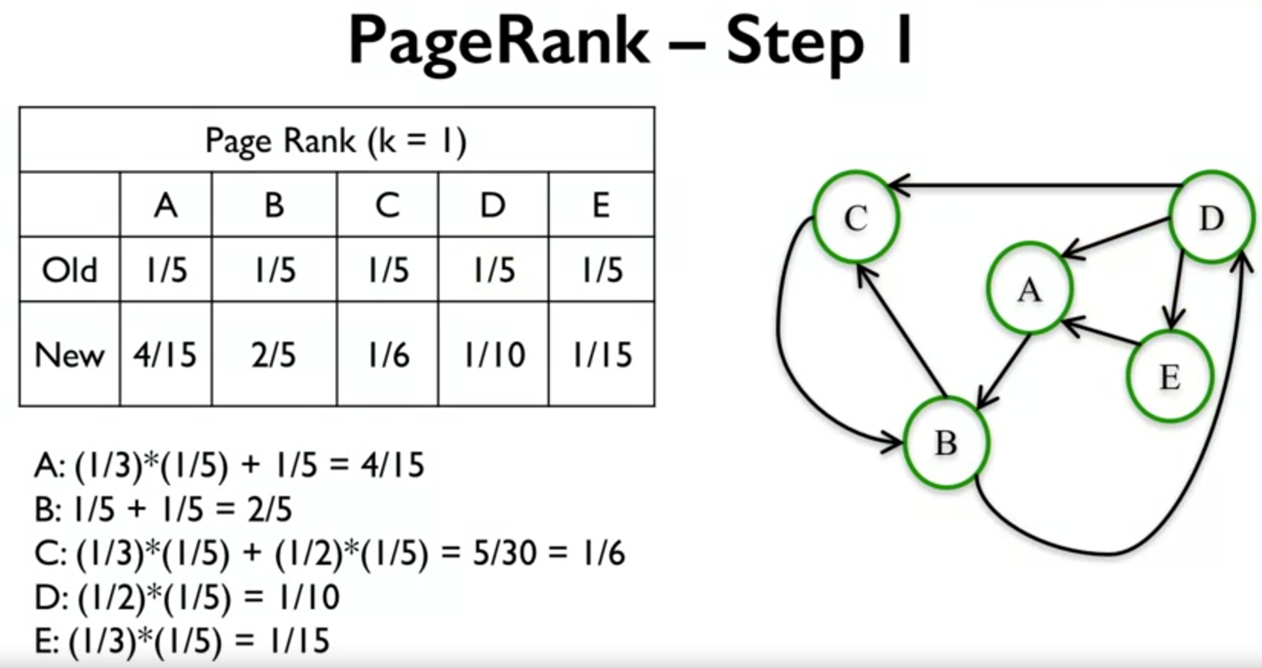

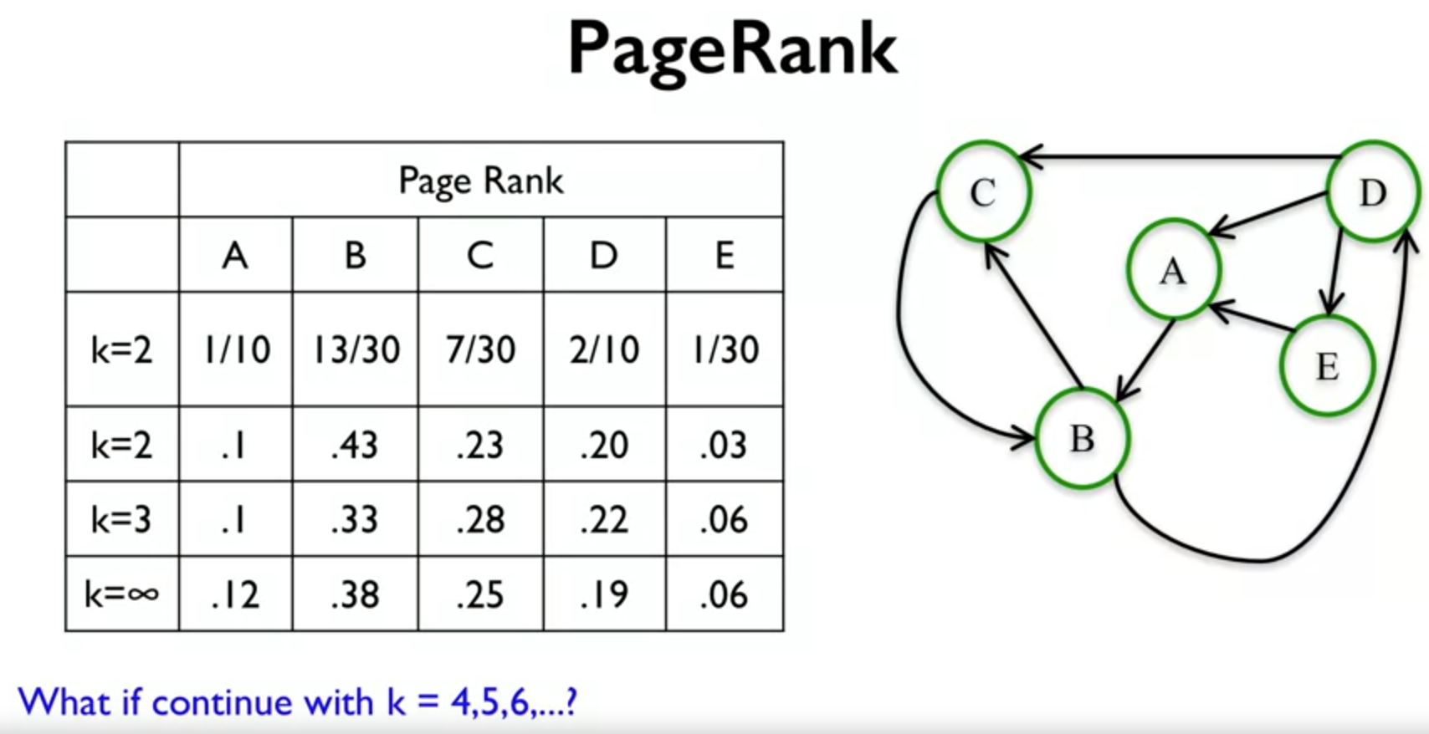

Interpreting PageRank values. It refers to the probability of landing in a particular node after a random walk of k steps.

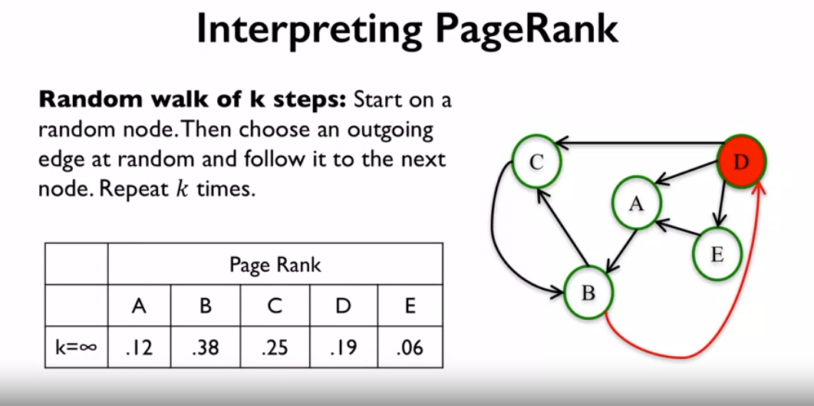

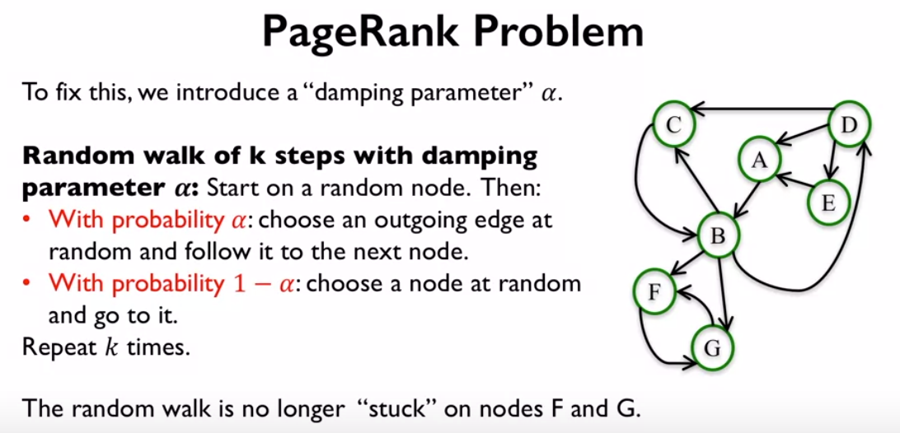

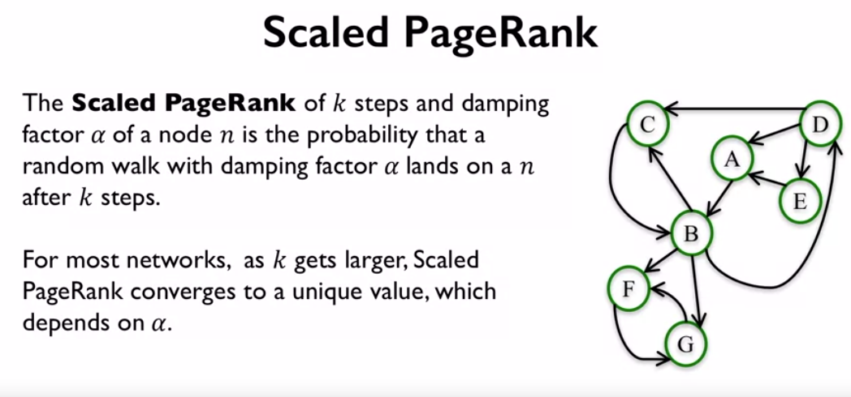

Usually a damping parameter of 0.8 or 0.9. And usually for large networks.

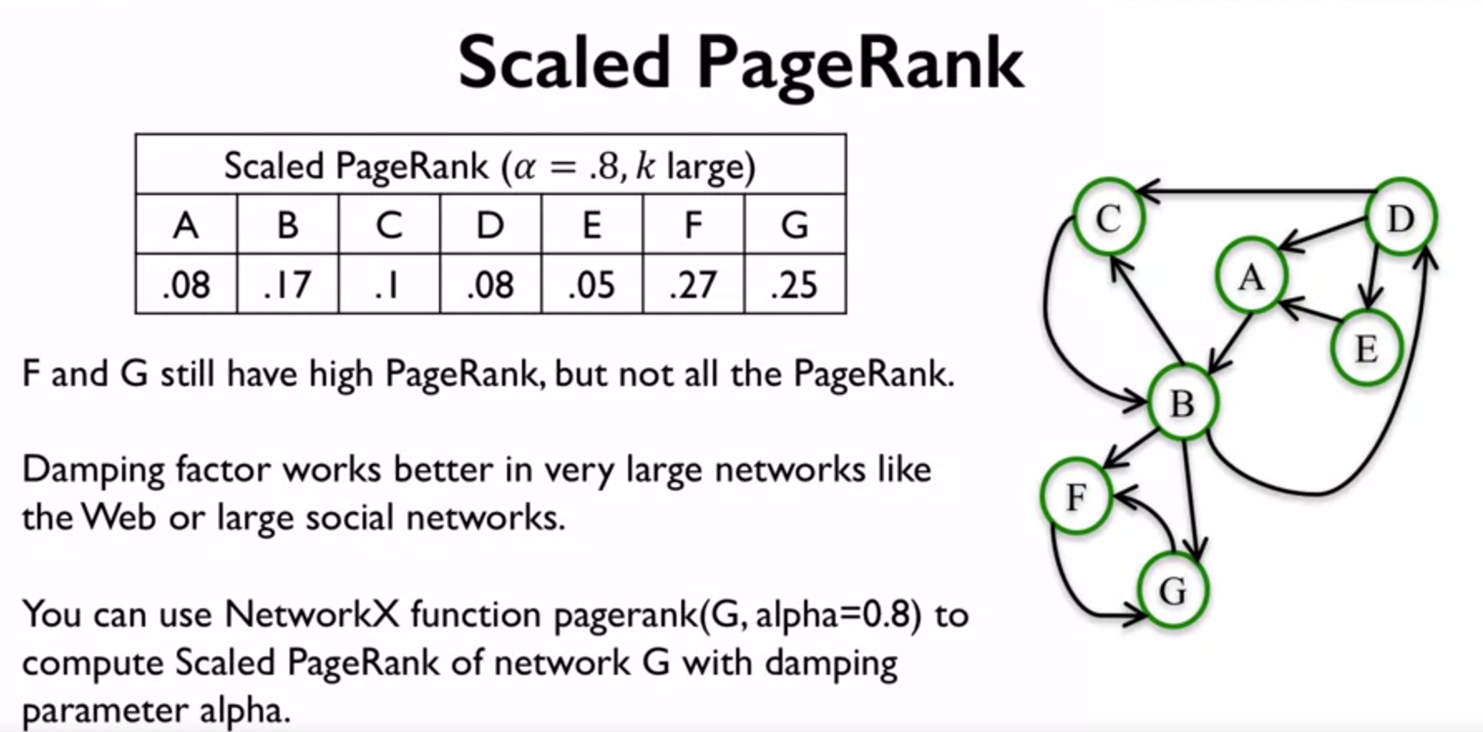

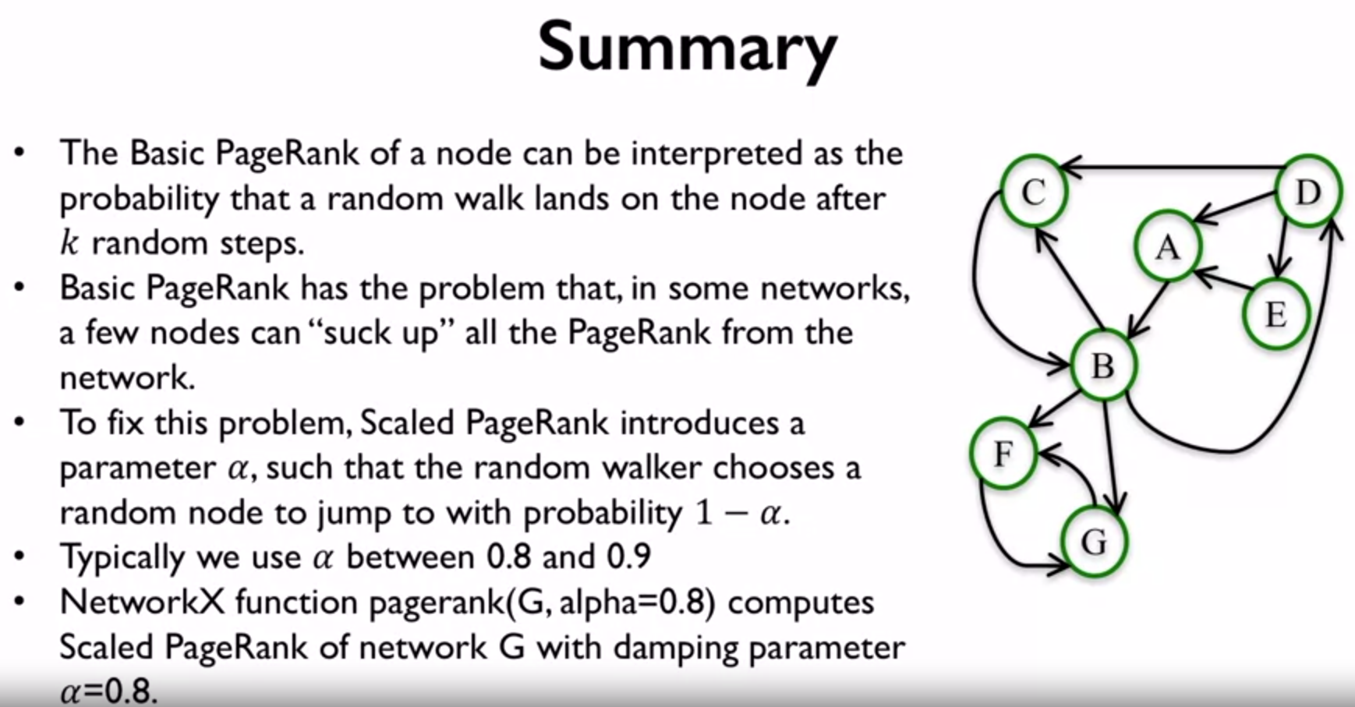

Hubs and Authorities

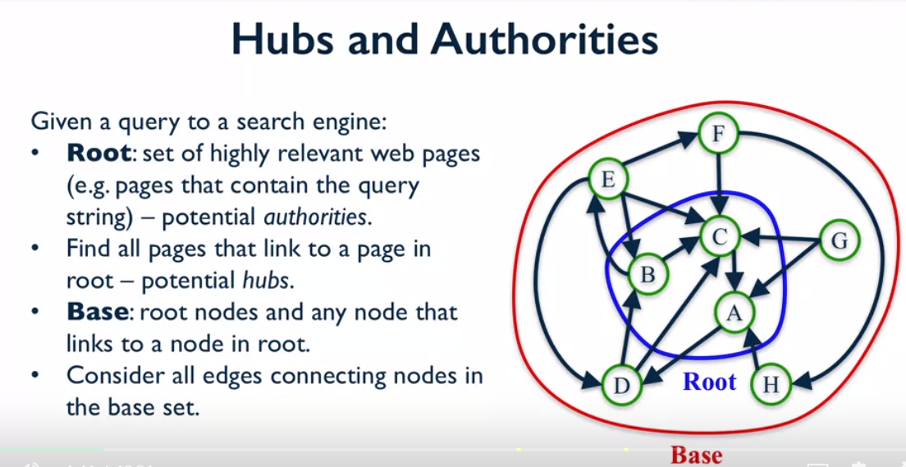



Authority score is looking at the in-degree score while hub score is looking at the out-degree score for the first iteration.

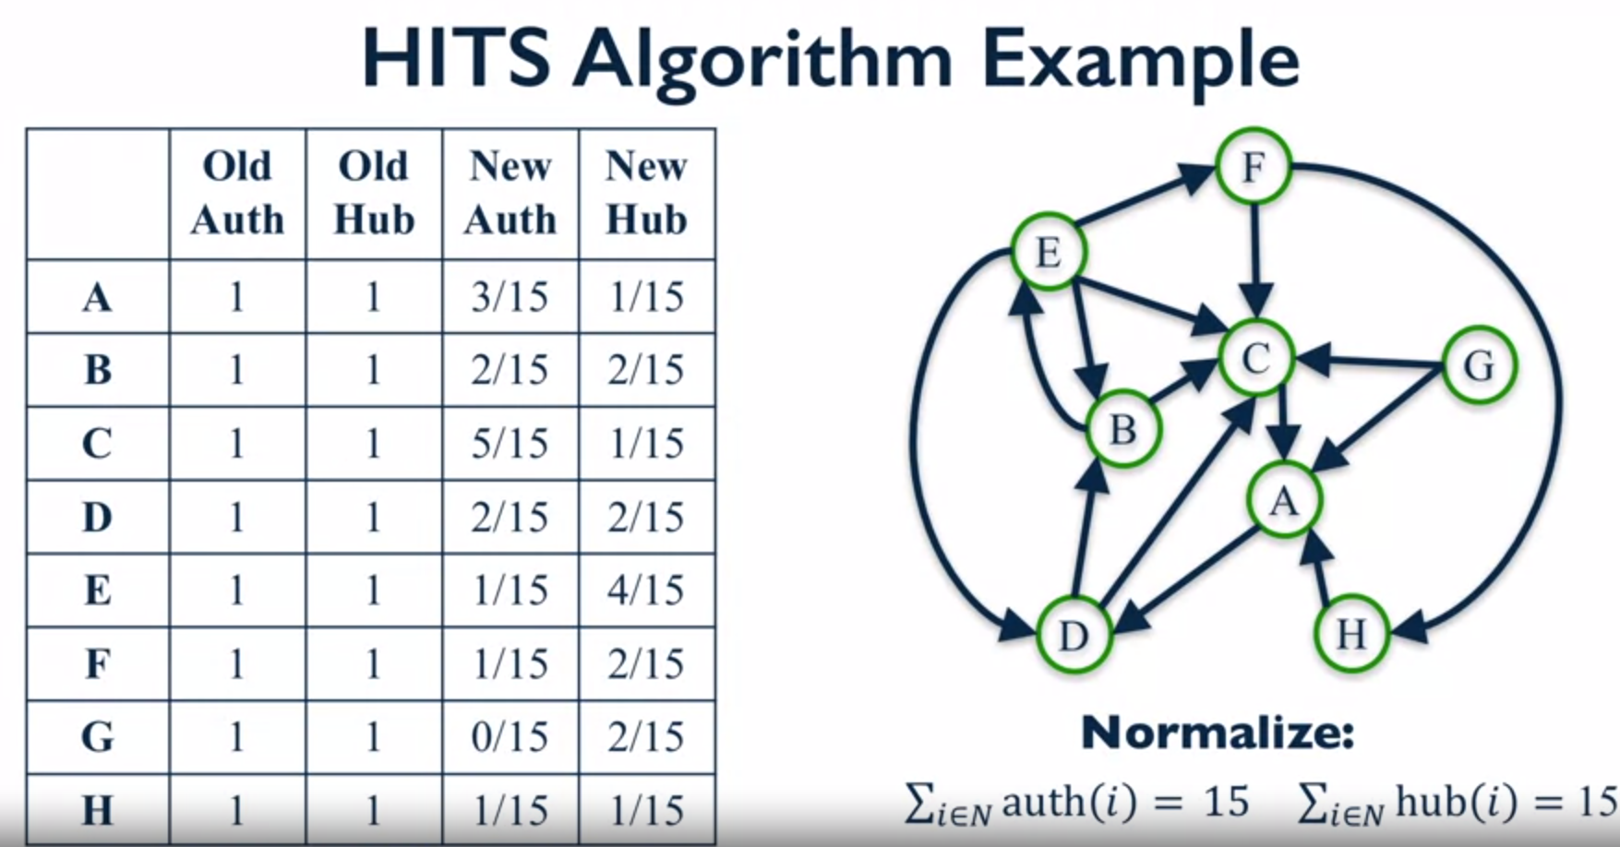

With K iterations, some of the hub/authority scores for certain nodes will converge, while for other nodes it will still fluctuate. But all the scores will converge as K -> infinity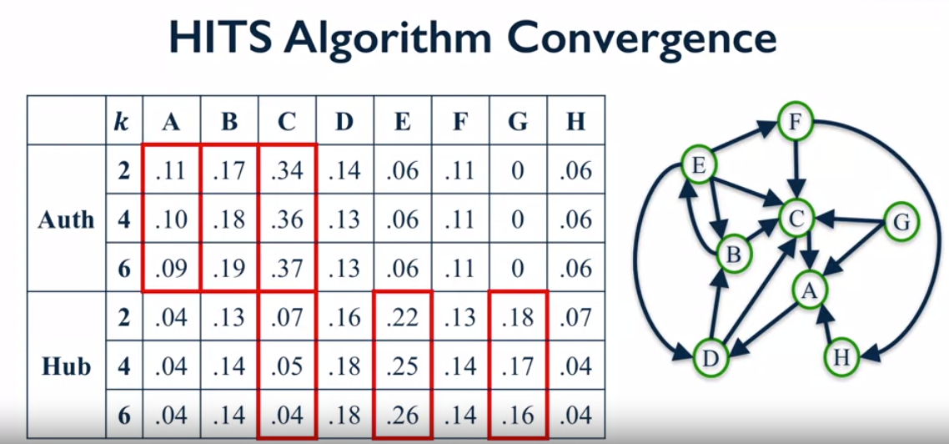

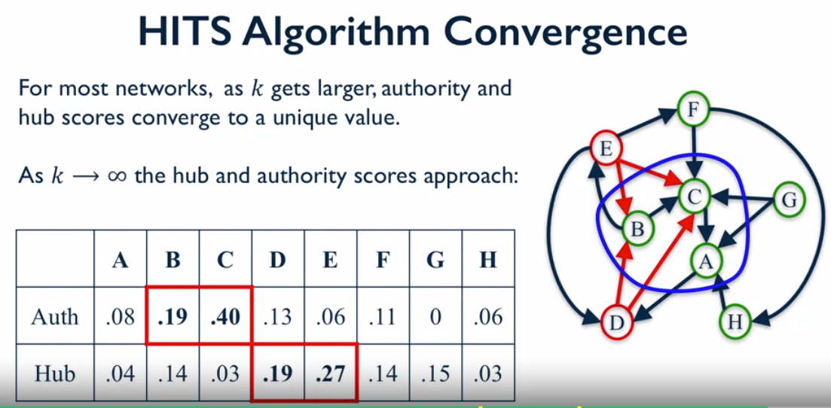 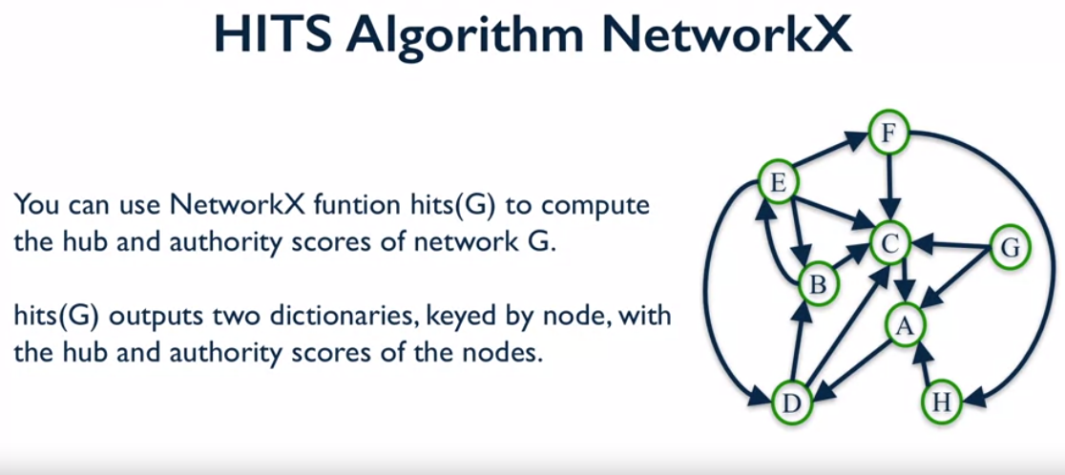

Comparing different Centrality measures

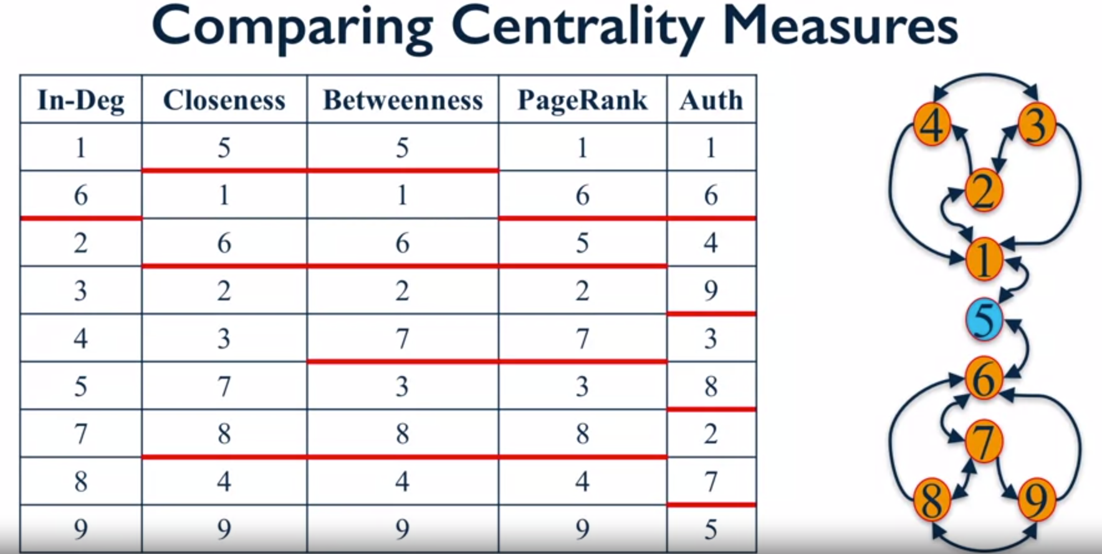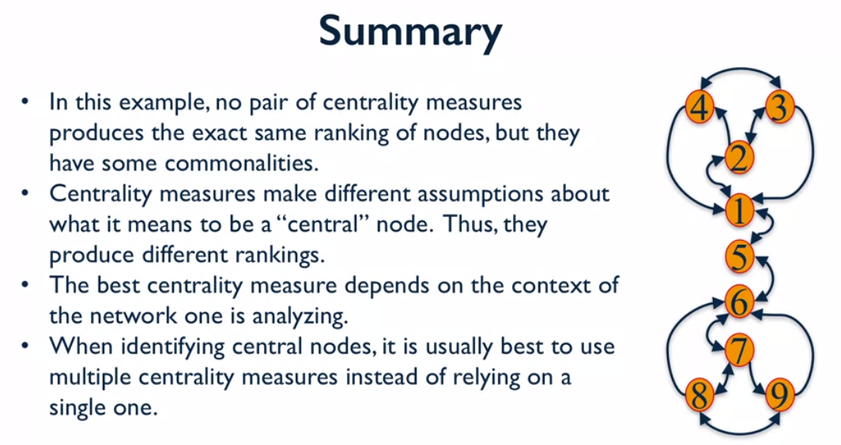

Preferential Attachment Model

Distribution of degrees in a graph is the probability distribution of the degrees over the entire network

degrees = G.degree()

degree_values = sorted( set( degrees.values() ) )

histogram = [list(degrees.values()).count(i)/float(nx.number_of_nodes(G) for i in degree_values]

plt.bar(degree_values,histogram)

plt.xlabel(‘Degree’)

plt.ylabel(‘Fraction of nodes’)

In-degree Distribution is the probability distribution over the entire network for the in-degrees.

in_degrees = G.in_degree()

in_degree_values = sorted( set( in_degrees.values() ) )

histogram = [list(in_degrees.values()).count(i)/float(nx.number_of_nodes(G) for i in in_degree_values]

plt.bar(in_degree_values,histogram)

plt.xlabel(‘In Degree’)

plt.ylabel(‘Fraction of nodes’)

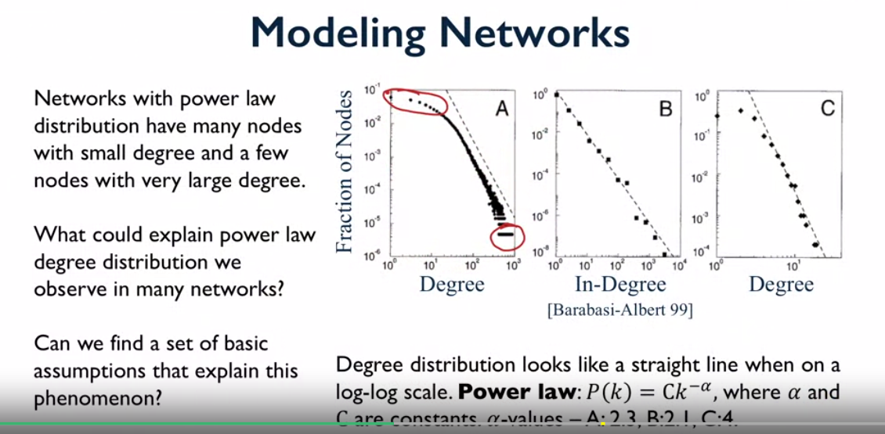

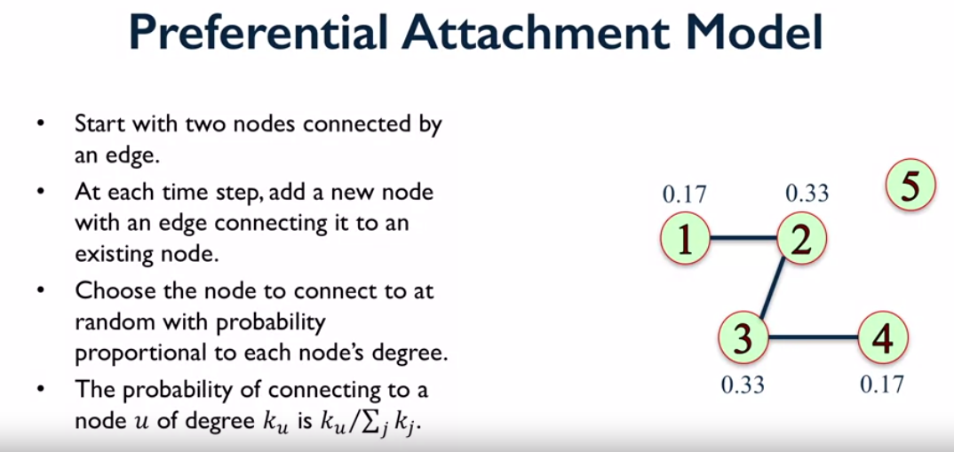 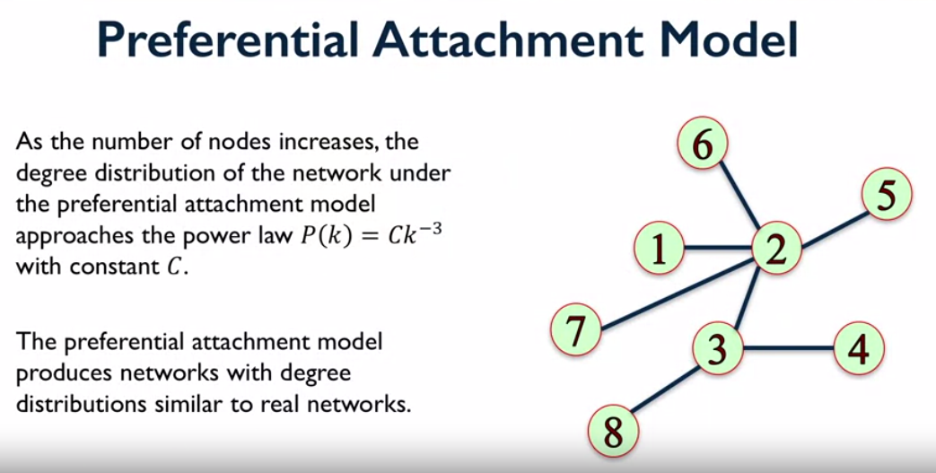 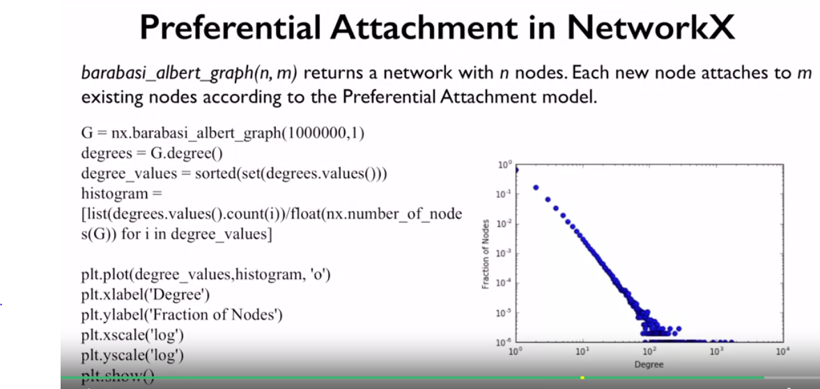 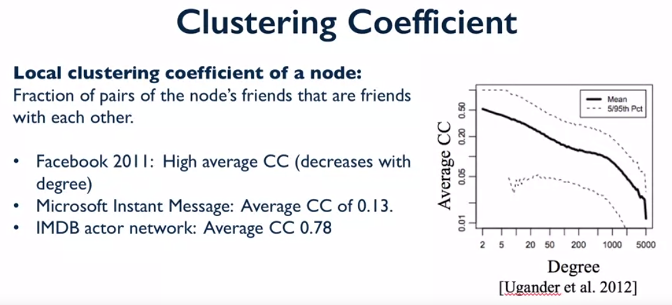

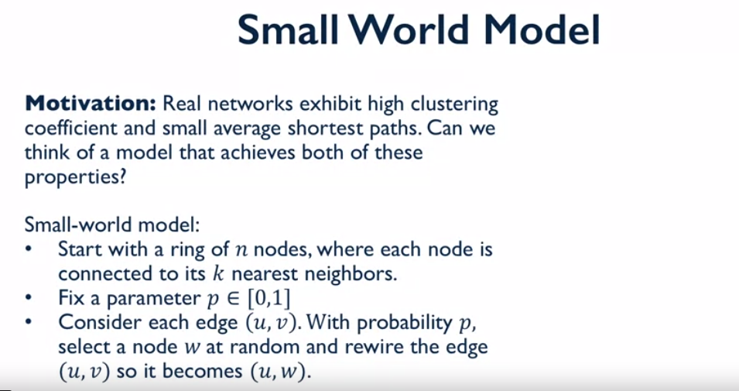 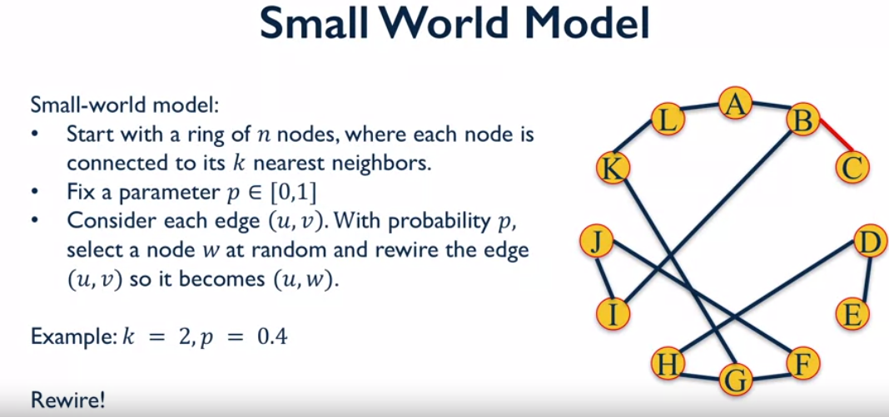 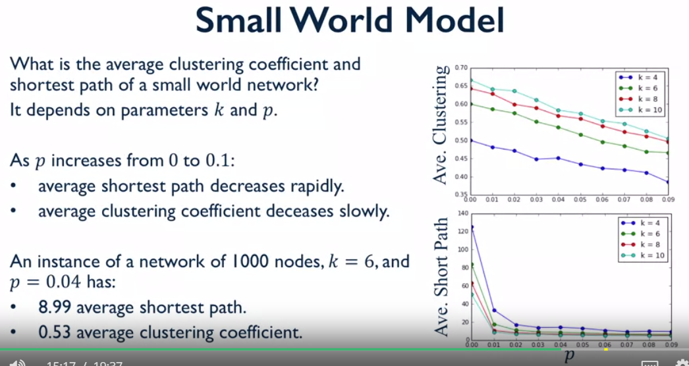 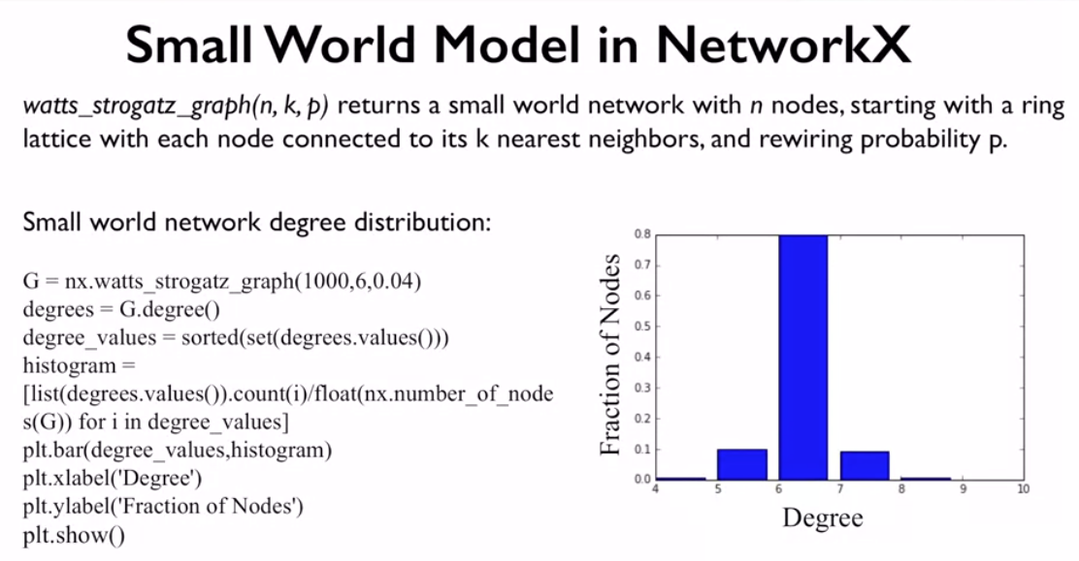 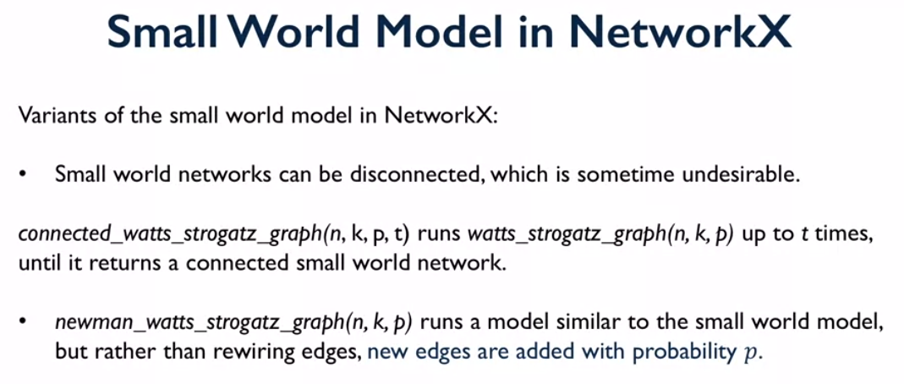

Link Prediction

What new edges are likely to form in this graph? Given a pair of nodes, how do we assess whether they are likely to connect?

7 measures:

1. Common Neighbours
2. Jaccard Coefficient
3. Resource Allocation Index
4. Adamic-Adar Index
5. Preferential Attachment Score
6. Common Neighbour Soundarajan-Hopcroft Score (require community information)
7. Resource Allocation Neighbour Soundarajan-Hopcroft Score (require community information)

